Name: Miheer Abhyankar

Assignment - Banking System

SQL

Q -1. Write an SQL query to retrieve the name, account type and email of all customers.

Query - SELECT CUSTOMERS.first_name, CUSTOMERS.last_name, ACCOUNTS.account_type, CUSTOMERS.email

FROM CUSTOMERS

JOIN ACCOUNTS ON CUSTOMERS.customer_id = ACCOUNTS.customer_id;

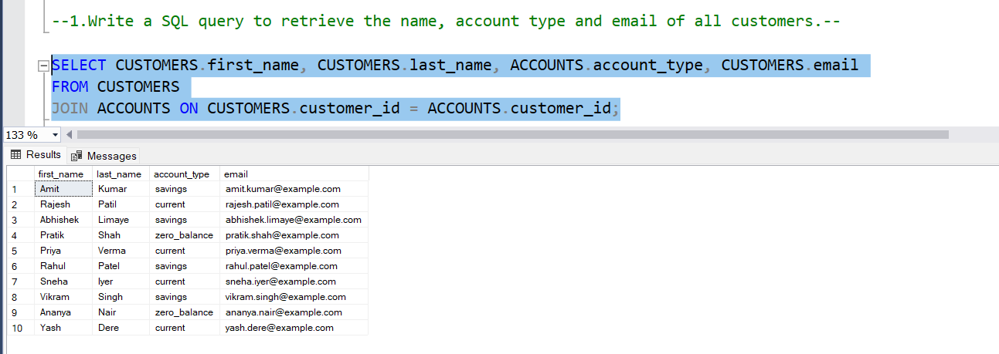

Q - 2. Write an SQL query to list all transaction corresponding customer.

Query - SELECT CUSTOMERS.first_name, CUSTOMERS.last_name, TRANSACTIONS.transaction_type, TRANSACTIONS.amount, TRANSACTIONS.transaction_date

FROM CUSTOMERS

JOIN ACCOUNTS ON CUSTOMERS.customer_id = ACCOUNTS.customer_id

JOIN TRANSACTIONS ON ACCOUNTS.account_id = TRANSACTIONS.account_id

ORDER BY CUSTOMERS.customer_id, TRANSACTIONS.transaction_date;

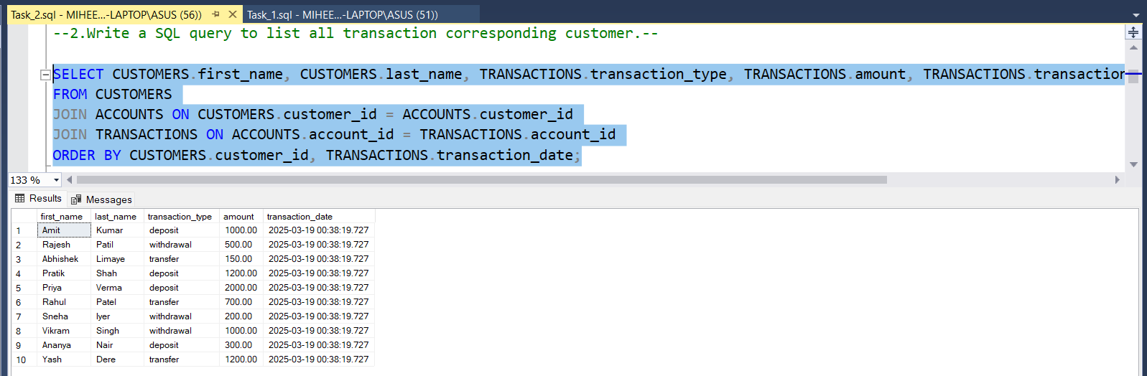

Q - 3. Write an SQL query to increase the balance of a specific account by a certain amount.

Query - UPDATE ACCOUNTS

SET balance = balance + 500

WHERE account_id = 1;

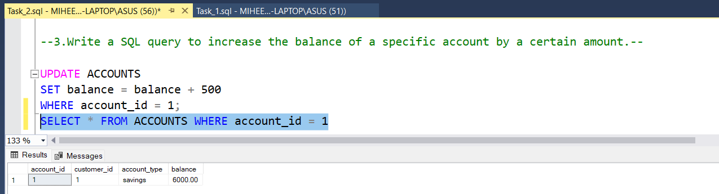

Q – 4. Write an SQL query to Combine first and last names of customers as a full_name.

Query - SELECT CONCAT(first_name, ' ', last_name) AS full_name

FROM CUSTOMERS;

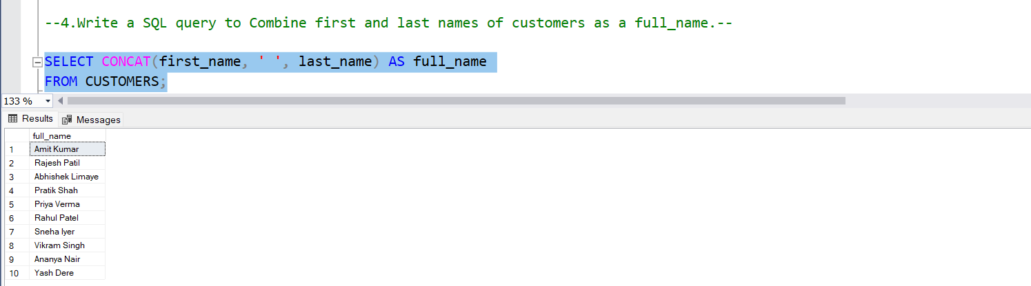

Q - 5. Write a SQL query to remove accounts with a balance of zero where the account

type is savings.

Query - DELETE FROM ACCOUNTS

WHERE balance = 0 AND account_type = 'savings'

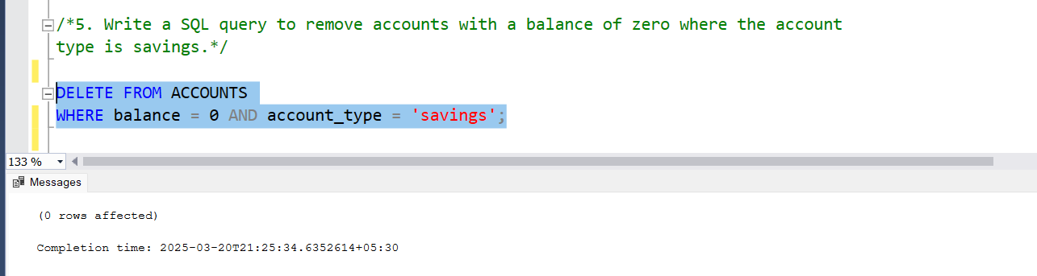

Q - 6. Write an SQL query to Find customers living in a specific city.

Query - SELECT * FROM CUSTOMERS WHERE address LIKE '%Pune%';

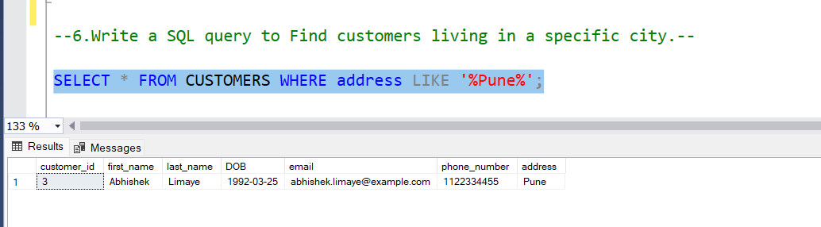

Q - 7. Write an SQL query to Get the account balance for a specific account.

Query - SELECT balance FROM ACCOUNTS WHERE account_id = 3;

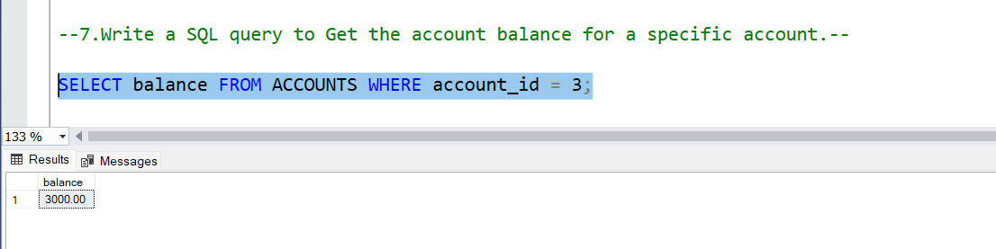

Q – 8. Write an SQL query to List all current accounts with a balance greater than $1,000.

Query - SELECT * FROM ACCOUNTS WHERE account_type = 'current' AND balance > 1000;

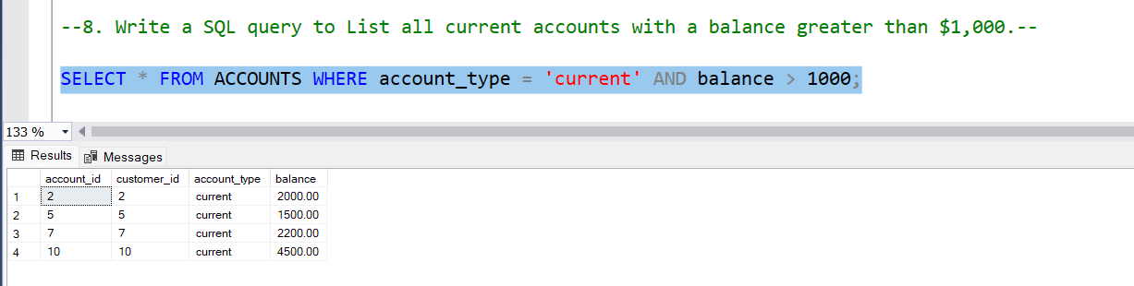

Q - 9. Write an SQL query to Retrieve all transactions for a specific account.

Query - SELECT * FROM TRANSACTIONS WHERE account_id = 2;

